RECONNECTING WITH RESILIENCE
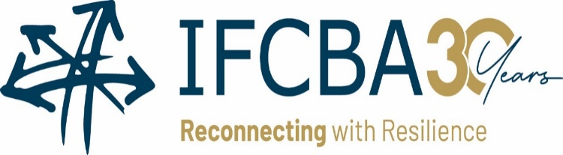
IFCBA 2022 Global Trade Conference
jw marriott singapore south beach hotel, Singapore
DECEMBER 12-14, 2022

DELEGATE REGISTRATION FORM (one form per delegate)

to book accommodation at the JW Marriott Hotel, please use this link:
https://www.marriott.com/event-reservations/reservation-link.mi?id=1664886124914&key=GRP&app=resvlink
DEADLINE: NOV 14, 2022

OPTIONS FOR RETURNING COMPLETED FORM: E-mail (Scan form): ifcba@ifcba.org Fax: 1-613-562-3548

Delegate Information will be reproduced in materials provided to delegates and qualified sponsors.

If you do not wish to have your information included, please check this box
Full name (as shown on passport):
First Name, Family Name for Name Badge:
Association/Company:
Street address:
City: | Country:
Email: |  | Mobile:
Companion name(s) (if applicable):
Special requirements (accessibility, dietary, etc.):
VISA/LETTERS OF INVITATION
Delegates are responsible for making their own visa arrangements, if required.
Visa Support Letter Required: Yes
REGISTRATION FEES - Registration is confirmed only when full payment is received. |  |  | # | TOTAL
Member Delegate (Conference Dec 12-13, for IFCBA Directors & Members Board meeting Dec 14): Includes all seminar sessions and materials, refreshment breaks, luncheons, Singapore Night Zoo tour and dinner |  | 700 USD
Non-Member Delegate Seminar series only (Dec 12-13): Includes all seminar sessions and materials, refreshment breaks, luncheons and cocktail reception |  | 745 USD
Companion: Includes Singapore Night Zoo tour and dinner |  | 125 USD
TOTAL PAYMENT DUE |  |  | USD
PAYMENT INFORMATION
Method of payment: VISA MasterCard
Credit Card number: |  | Expiry date:
Cardholder’s name:
Signature:
REGISTRATION CLOSURE, REFUND AND CANCELLATION POLICY: There will be no refund for cancellations received on or after December 5, 2022. A registration will be cancelled only upon receipt of written instructions by the IFCBA Secretariat. Substitutions are permitted.

